# Introduction

The objectives of this ACW is to research, design and implement a distributed, physically-based modelling demonstrator for a series of gravity wells. The world would consist a large plane that is surrounded by a circular wall. A large number of spheres are placed on surface. The physics simulation would be run across a number of peer. Each peer would control an individual gravity well and display a consistent view of the world based on the position of the gravity well. Attracting or repelling forces could also be applied to spheres via the gravity well.

# System Architecture

The UML class diagram of the project is shown in Appendix A to establish a brief overview how classes are developed to provide different functions.

The Classes are mainly distributed to 3 aspect: Visualisation, Networking and Simulation.

## Class Description

### WinMain

Software entry point for Window

### System Class

System Class manage the window framework and maintain the lifecycle of all other classes. When the system initialise different classes, new threads would be created and assigned to specific processors. Detail of threading and process affinity would be discussed in detail later.

### Config Class

Config Class would keep hold of all the configuration data until the life cycle of the application finished. While it is being initialised, a configuration file with the name “config.txt” would be read in order to obtain the variables to set up the simulation scene. In Appendix C, a template of configuration file has been shown that allow users to set starting values for different variables, such as Screen size, radius of the ground surface, Ports for network connections etc..

According to the specification, certain values have to be changeable during the software operating including target updating frequency for graphics, physics and network classes, elasticity, frictional forces and timescale.

### StepTimer Class

The class provides elapsed time information and fixed time step mode. Be setting target elapsed seconds between each update, the timer would run and call the update in order to meet the expected fixed update time as close as possible. For physics, graphic and simulation class, they would initialise their own timer with target elapsed time from the Config class. As a result, users would be able to control different updating frequency on rendering, simulating and networking.

### Graphic Class

The Graphic Class is developed to handle the visualisation of the physics modelling. To visualise objects on the screen, the Graphic Class manage the Direct3D Class and Camera Class and monitor user input at each frame.

### D3D Class

This is a class to handle all the Direct3D functions. It maintains the ID3D11Device and Device Context and set up the characteristics of the swap chain in order to create a swap chain instance.

### Camera Class

The Camera Class handles the view matrix and the location of camera. If the camera is updated to a new location or rotation, a new view matrix will be calculated.

# Appendix A: UML Class Diagram

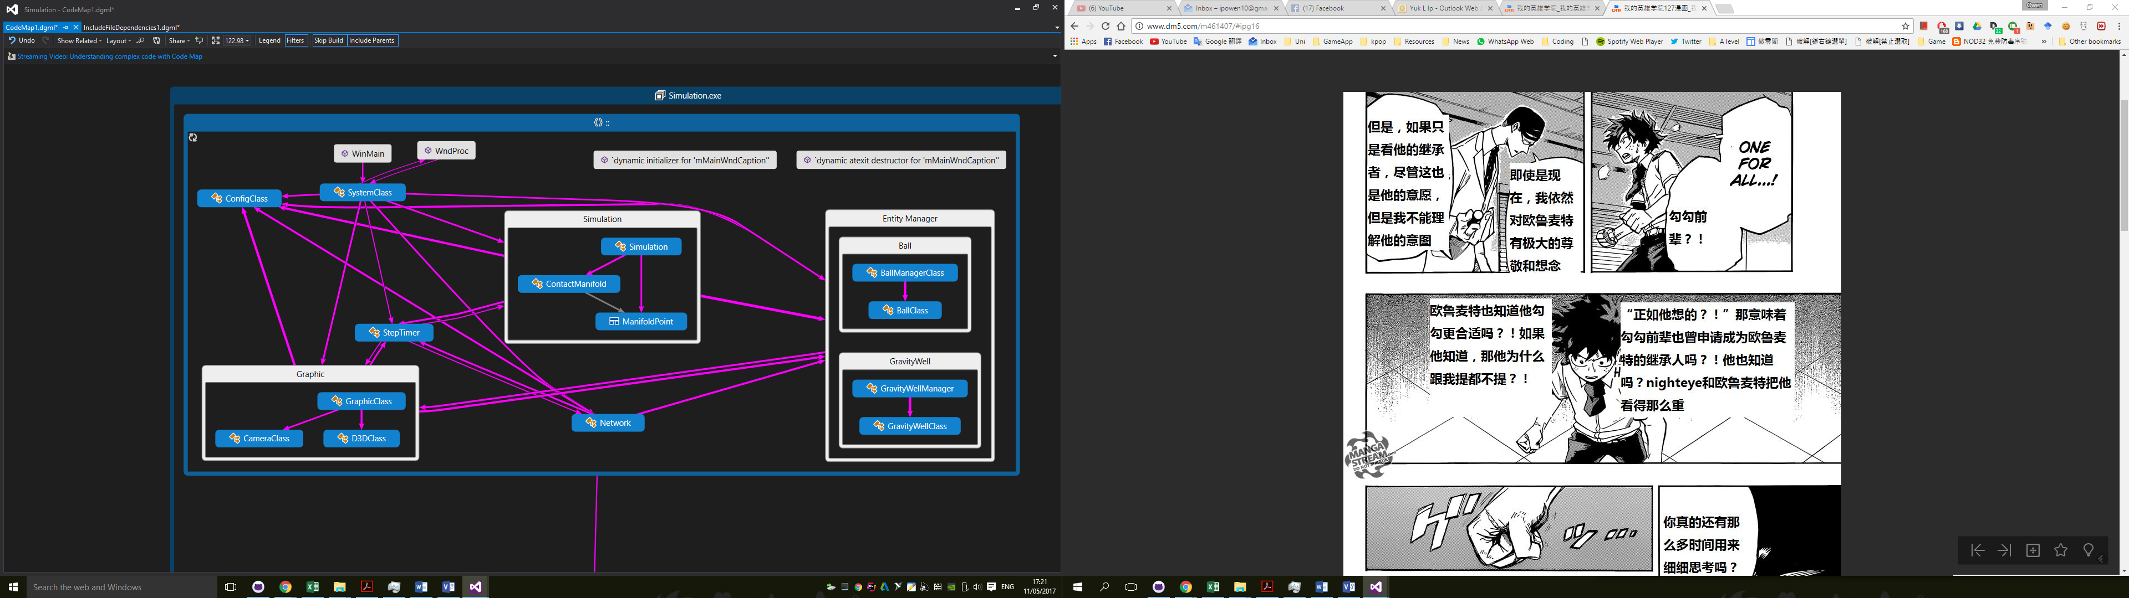

Appendix B: Sequence Diagram

# Appendix C: Configuration file template

